100mm Mirror Ferrocell Setup and Suggested Use

1. Position the cell on a flat, non-ferrous surface with the mirror on the bottom.
2. Provide a very bright light source (halogen, laser or hi-power LED) at a 45 degree angle down into the cell.
3. Provide a screen or other method for capturing the viewed image of the reflected beam(s) or view directly into the cell (not with laser!).
4. Darken the room for viewing.
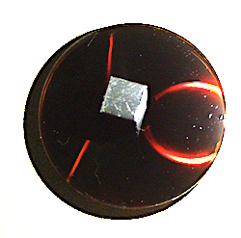
5. Place a magnet on top of the cell or under the mirror to activate the particles.

6. Change magnet orientation to see how the field affects the lights response.

------------------------------------------------------------------------------------------------------------
Wait 10-30 seconds for image to manifest. Move magnets position often. Resting magnet in one position for long periods of time (> 2 min) may burn the inside surface of the glass, creating a blurred view in the affected area. Be cautious with large ring magnets- they are more likely to burn the cell than smaller diameter poles will.
……………………………………………………………………………………………………………………………...
> Do not place magnets of opposite polarity on both sides of Ferrocell at the same time or damage to the seal may occur.
> Clean glass surfaces with glass cleaner and lint free towel or lens paper to remove smudges or fingerprints.
> Your Ferrocell has a two (2) year replacement (or repair) warranty. You only need to pay shipping back to us if cell becomes defective.
> Any questions, please contact info@ferrocell.us for help.

